LAB 1
You can work on this lab in groups of 3-4. It is due Friday, January 29, 2016 before 5.00 pm. You can hand it in on Blackboard or the 801 homework box in the Statistics department break room 3rd floor Hardin Hall North Annex. Hand in only one Lab for your group. Make sure you include everyone’s name on the lab.

Graphical Techniques

A histogram breaks the range of values of a variable into intervals and displays only the count (or percent) of the observations that fall into each interval. The purpose of a histogram is to display the shape of a distribution.

To make a histogram:

- Divide the range of the data into classes of equal width- be sure to specify the classes precisely so that each observation falls into exactly one class.

- Count the number of observations in each class. These counts are called frequencies, and a table of frequencies for all classes is a frequency table.

- Draw the histogram.

Example: A random sample of 24 high school seniors were given a college entrance exam. The data are:
64 75 81 43 69 75
86 58 63 66 82 62
79 91 83 55 68 74
48 66 84 77 73 59

Step 1: Our classes will be: 40-49,50-59,60-69,70-79,80-89, and 90-99.

Step 2: the frequency table is:

Class | Count
40-49 | 2
50-59 | 3
60-69 | 7
70-79 | 6
80-89 | 5
90-99 | 1

Step 3: draw the histogram.
The stem and leaf plot is a quick and easy way to display data. It displays the shape of a distribution, without losing any information:

To make the plot:

- Separate each observation into a stem and a leaf. Stems may have as many digits as needed, but each leaf contains only a single digit.

- List the stems vertically in increasing order from top to bottom, draw a vertical line to the right of the stems, and add the leaves to the right of the line.

- Arrange the leaves in increasing order from left to right.

Example: College entrance exam data:

Step 1: In this case, the first digit is the stem and the second digit is the leaf:

Step 2: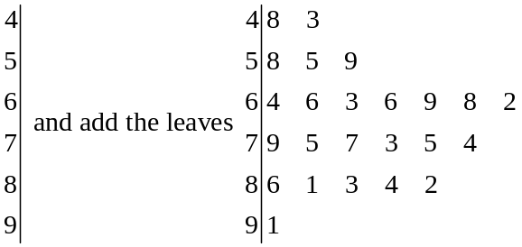

Step 3: order the leaves 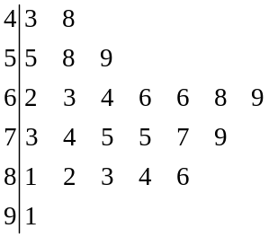

We can also do back-to-back stem and leaf plots:

Example: Heights were measured (to the nearest inch) of maize plants in adjacent rows which differed only in a pollen sterility factor

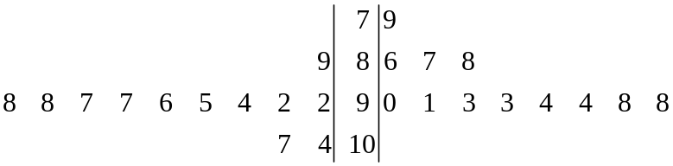
Creating a SAS dataset

- DATA SASdataset;

- INFILE ‘filename’; *

- INPUT variable list;

- assignment statements;

- IF [logical statement] THEN result; ELSE result;

- DATALINES; *

Data records go here

; note that you end the data records with a semicolon on a line at the end.

* Note: use either step 2 (when getting data from an ASCII file outside of your SAS program) or step 6 (when the data are typed right into your SAS program).

- DATA

Each data step begins with the word DATA. This creates a new, empty SAS dataset with the name given.

Example: DATA weight; creates a dataset called weight.

- INFILE

When the data you want to work with exist in an ASCII file outside of SAS use this statement.

Example: INFILE ‘c:\statistics 801\weight.dat’;

Tells SAS that your data are in the directory ‘c:\statistics 801’ in the file ‘weight.dat’.

- INPUT

The INPUT statement names the variables to be created and specifies the format for reading in the data.

General information for the INPUT statement:

  - Put a $ after the variable name if the variable contains character information
  - @n moves the pointer to the nth column of the data line
  - #n moves the pointer to the nth line of the data. This means that one SAS observation can get information from more than one line of the data file.
  - / moves the pointer to the next line of data.
  - @, trailing holds the pointer on the current line of the data file for the next INPUT statement. Normally, when SAS sees another INPUT statement it automatically moves the pointer to start reading the next line of data.
  - @@, trailing holds the pointer on the current line for other executions of the same INPUT statement. Normally, when SAS gets to the end of the INPUT variable list it moves the pointer to the next data line. The trailing @@ allows you to read more than one observation from each data line.

There are three basic forms of input (list input, column input and formatted input). You are allowed to mix the three input modes.

- LIST INPUT: INPUT variable 1 variable 2 ….;

This is the easiest way to input data and should be used whenever possible. The only rules are: put each observation on a separate line, and place at least one space between entries. Missing values are indicated by periods.
Example: DATA simple;
INPUT x y z;
DATALINES;
10 23 59
3 19 62
11 12 13
14 . 9.73
;
PROC PRINT;
RUN;

Which produces the following results:

OBS X Y Z
1 10 23 59
2 3 19 62
3 11 12 13
4 14 . 9.73

- COLUMN INPUT: INPUT variable1 startcol-endcol [decimals]
Variable2 startcol-endcol [decimals]
.
.;
Or INPUT @startcol variable1 [length].[decimals]
@startcol variable2 [length].[decimals]
.
.;

The data must be stored in the same columns on every record. Advantage: Can read columns more than once and in any order.

Example: DATA info;
INPUT name $ 1-5 area 6-8 phone 6-15 earn 16-20 2;
DATALINES;
Chris30182393232300
Kevin919832802319550
;
PROC PRINT;
RUN;
Which produces:

OBS NAME AREA PHONE EARN
1 Chris 301 3018239323 23.00
2 Kevin 919 9198328023 195.50

Note: The input line could have also been written:

INPUT @1 name $ 5. @6 area 3. @6 phone 10 @16 earn 5.2;

- FORMATTED INPUT: INPUT variable1 informat variable2 informat ...;

SAS has many types of INFORMATS (input formats) and FORMATS (output formats) available. You can read scientific notation, dates, times, dollars, etc. Refer to the SAS manual for specific input formats.

- Assignment Statements

Syntax: variable=expression;

Expressions can be:

- Numeric constants, character constants enclosed in single quotes, date or time constants
- Or can involve arithmetic operators
** (raise to a power), *(multiply), / (divide), +, -
- There are a few other miscellaneous operators. Assignment statements can be made up of any combination of operators.

Order of Priority:
- ()
- **
- * /
- + -
- otherwise left to right

Use parentheses when in doubt.

- IF-THEN-ELSE

Syntax: IF [logical statement] THEN result; ELSE result;

A logical statement contains a variable, a comparison operator and either a constant or another variable. If the statement is true then SAS executes the result. If it is false then SAS executes the ELSE result. IF no ELSE exists, then SAS goes to the next line.

- Comparison operators 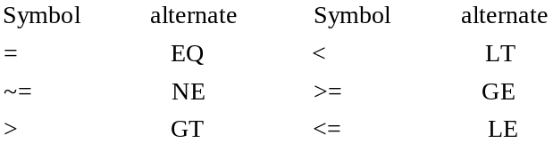

- Logical operators 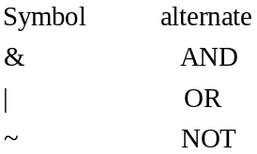

Example: DATA example;
INPUT name $ test hwk;
IF test GE 60 or hwk GE 60 THEN grade=’pass’;
ELSE grade=’fail’;
Avg=(test+hwk)/2;
DATALINE;
Meldrick 50 40
John 75 55
Tim 80 90
Frank . 95
Stan 45 59
Kay 60 75
Al 85 .
Beau 60 70
Steve 50 25
;
PROC PRINT;
RUN;

Which produces the following output:

OBS NAME TEST HWK GRADE AVG
1 Meldrick 50 40 fail 45
2 John 75 55 pass 65
3 Tim 80 90 pass 85
4 Frank . 95 pass .
5 Stan 45 59 fail 52
6 Kay 60 75 pass 67.5
7 Al 85 . pass .
8 Beau 60 70 pass 65
9 Steve 50 25 fail 37.5

- DATALINES

The DATALINES statement says that data lines are to follow. It must be the last SAS statement in the data step (if it is used at all). When typing the data lines into the program, DO NOT put a semicolon after any of the lines of data (not even the last one). See the examples in the input section of this handout.

SAS code for creating a histogram and stem and leaf plots for the problem #2 in the assignment:

Note that for the following SAS code that the parts that you type in exactly are all BOLD UPPERCASE, while the variables that you need to enter are lower case and italicized. For example variable is what you called the gain when you read in the data, source is what you called the source of fat, and amount is what you called the amount of fat.

PROC PRINT;
RUN;

PROC GCHART; *for producing a histogram;
VBAR variable/LEVELS=number of levels SPACE=0; *number of levels are the number of bars you want;
RUN;

*note that before running the univariate procedure you need to sort the data by;
* the by variables;
PROC SORT;
BY source amount;
PROC UNIVARIATE PLOT; *give stem-and-leaf plots and boxplots;
VAR variable;
BY source amount;
RUN;

Assignment Lab 1

1) To estimate the number of trees on a tree farm, a farmer divided the farm into 1,000 small grids. He then randomly selected 20 grids and counted the number of trees with the following results

79 86 83 98 67
99 62 93 84 90
68 100 83 70 75
92 112 74 89 95

a) Draw a histogram of these data (By Hand).

b) Construct a stem and leaf plot of this data (By Hand)

We will usually create histograms and stem and leaf plots using the software package SAS.

2) These data come from an experiment to study the gain in weight of rats fed on four different diets, distinguished by amount of protein (low and high) and by source of protein (beef and cereal).

Beef/Low Beef/High Cereal/Low Cereal/High
90 73 105 98
65 102 95 79
90 123 97 54
69 104 79 111
86 82 89 95
61 107 78 86
72 100 74 81
90 87 67 79
96 119 89 87
75 120 58 92

a) Write a program to read the data into SAS
b) Print the data (not to the printer, but using Proc Print).
c) Make a histogram of the data (see program above, making one histogram for variable “weight gain”)
d) Sort the data, and make stem and leaf plots for each amount/source combination (Should have four total plots). (see program above)

